Activity Diagrams
UC-01: User Registration
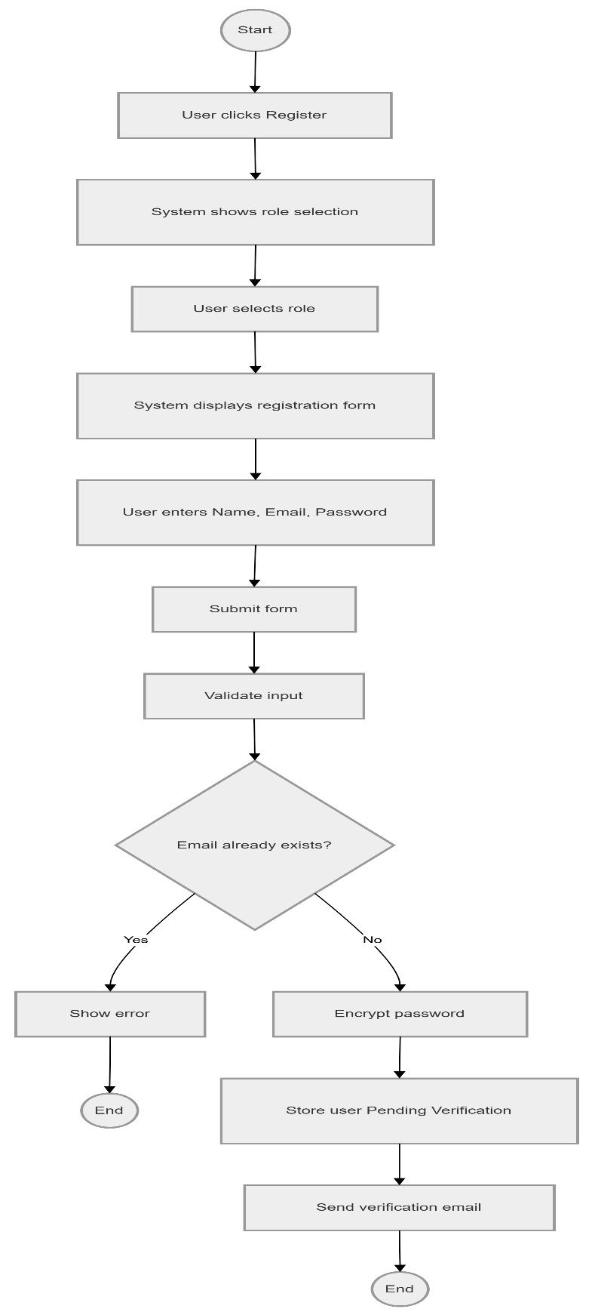

UC-02: User Login

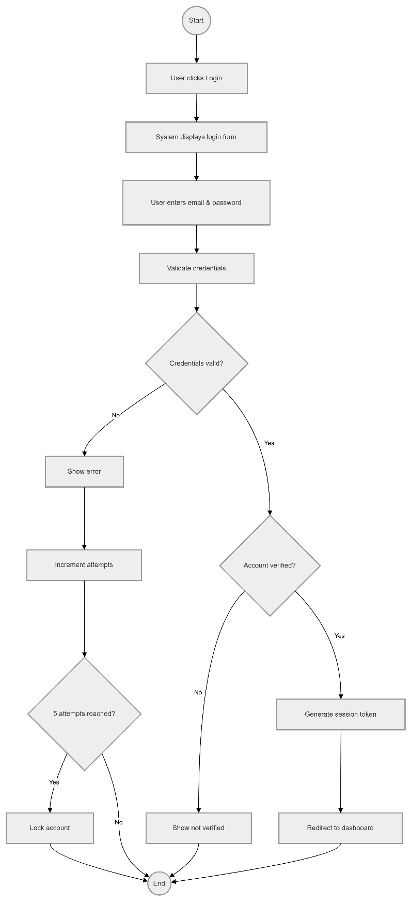

UC-03: Password Recovery
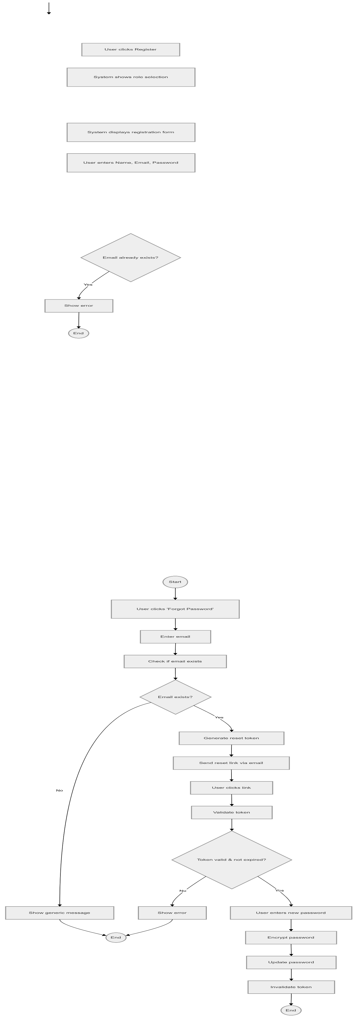

UC-04: Manage System Users
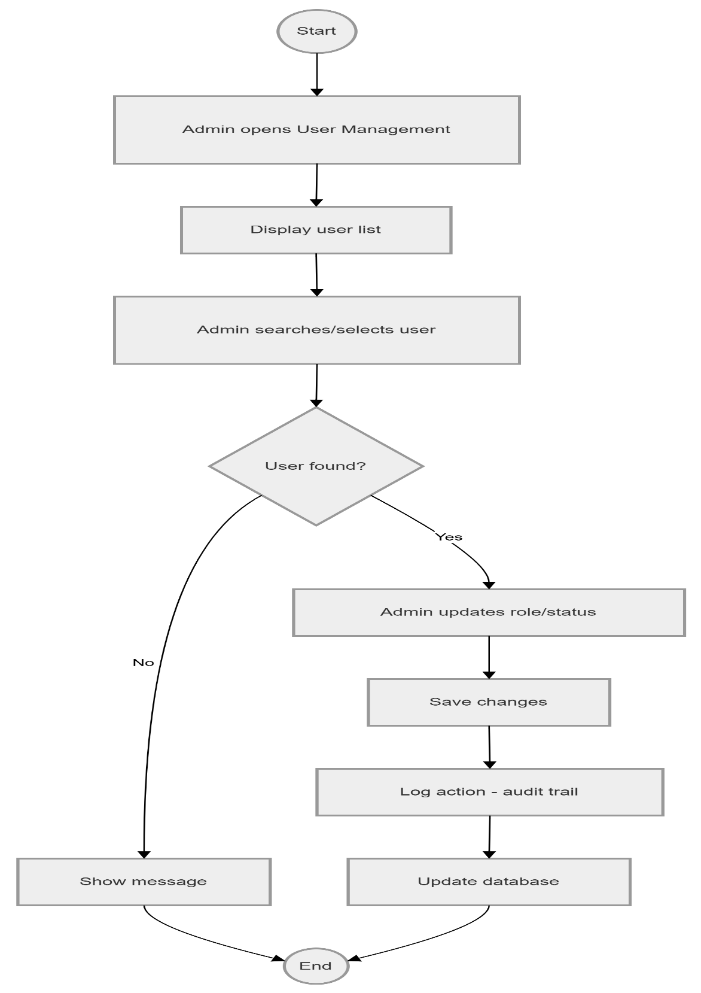

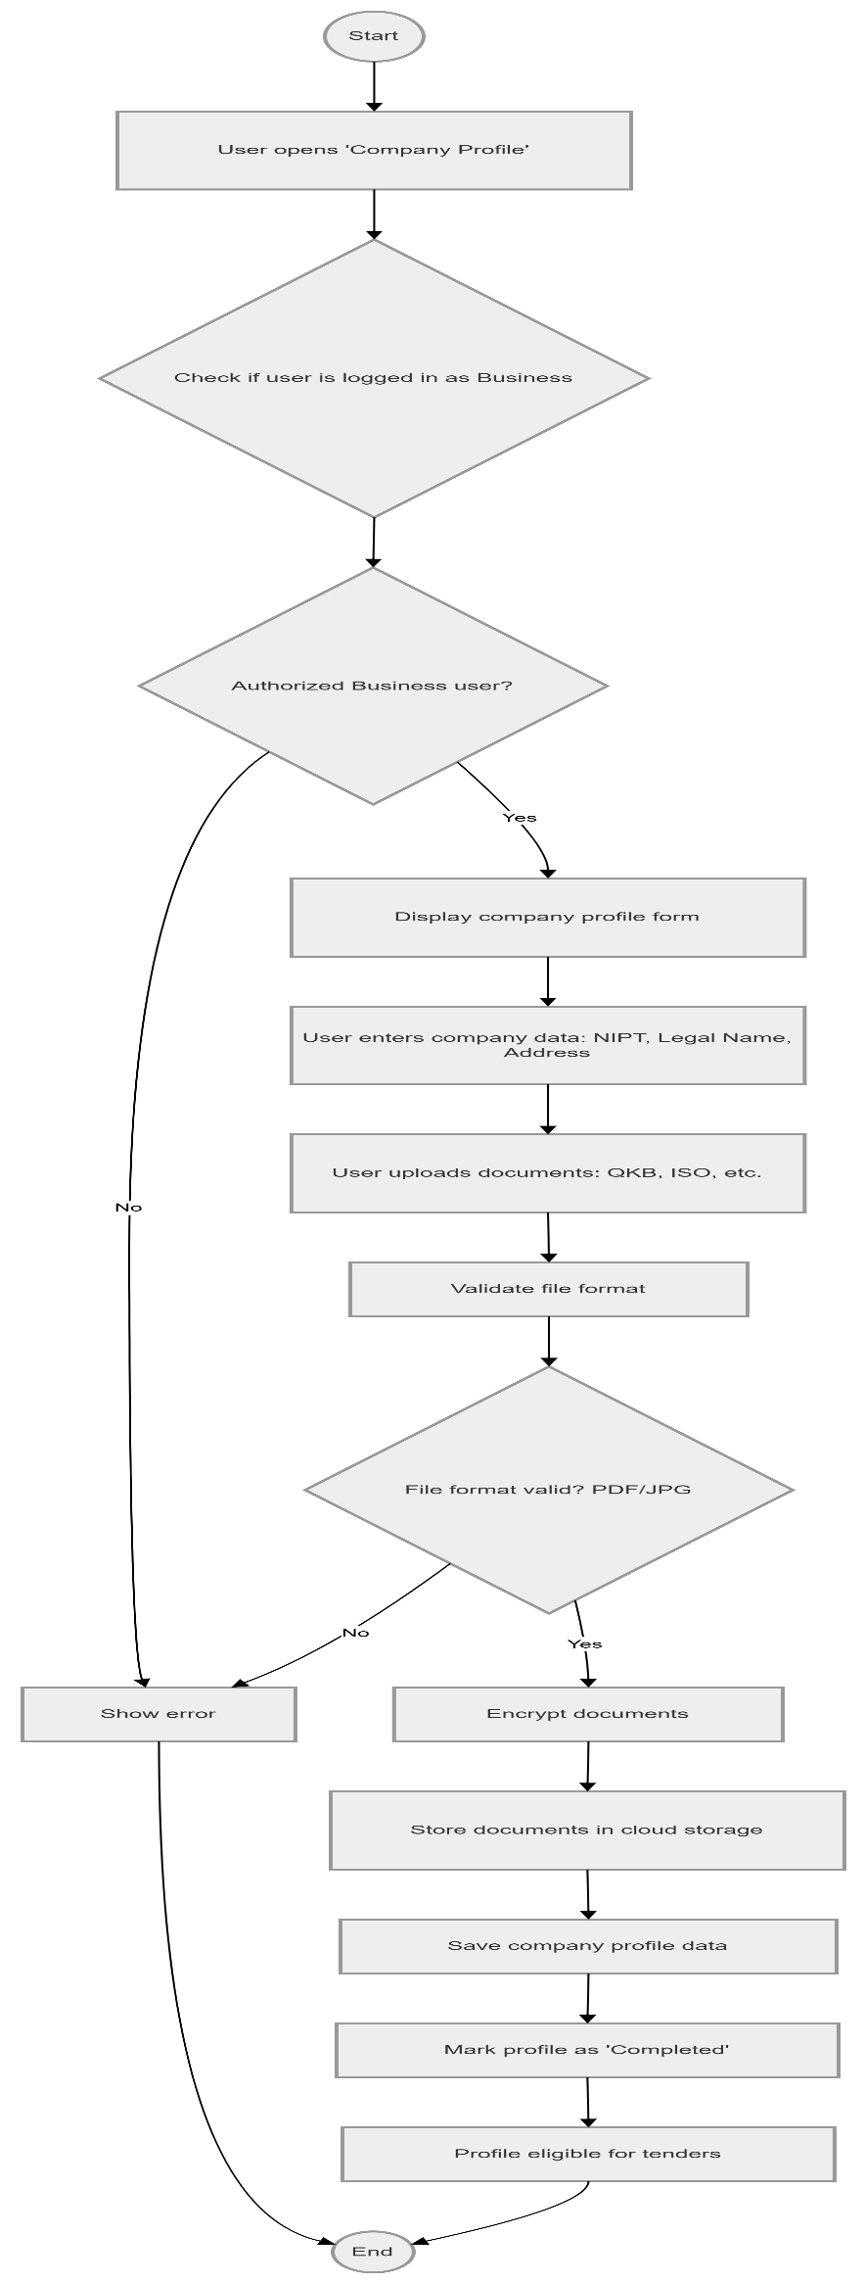
UC-05: Register Company Profile

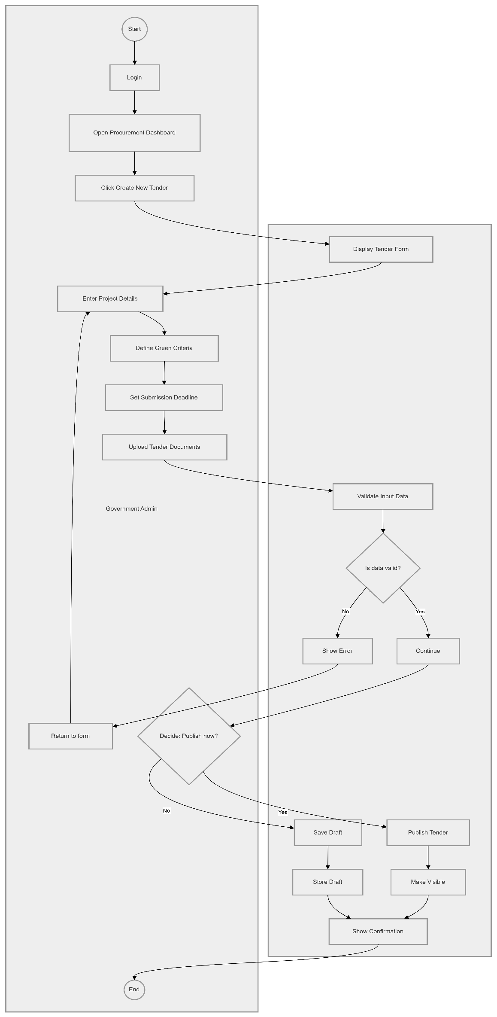
UC-06: Create New Tender

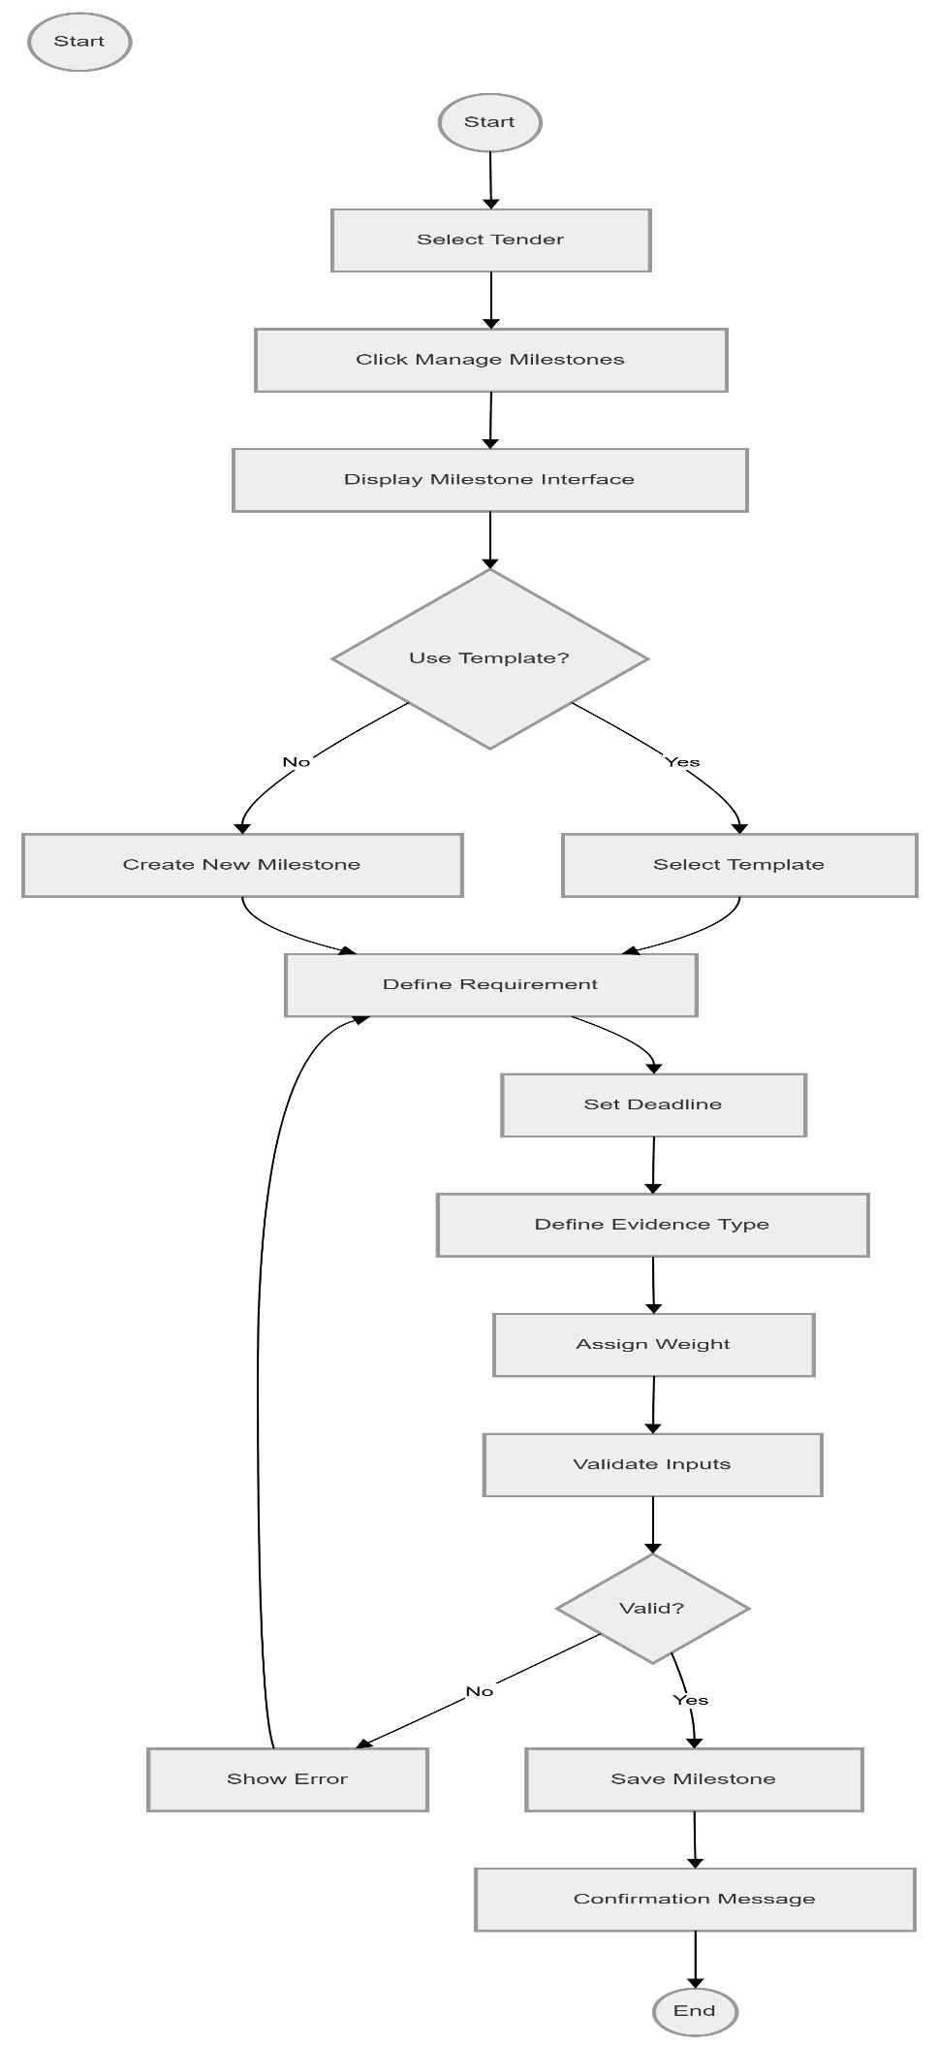
UC-07: Define Eco-Milestones

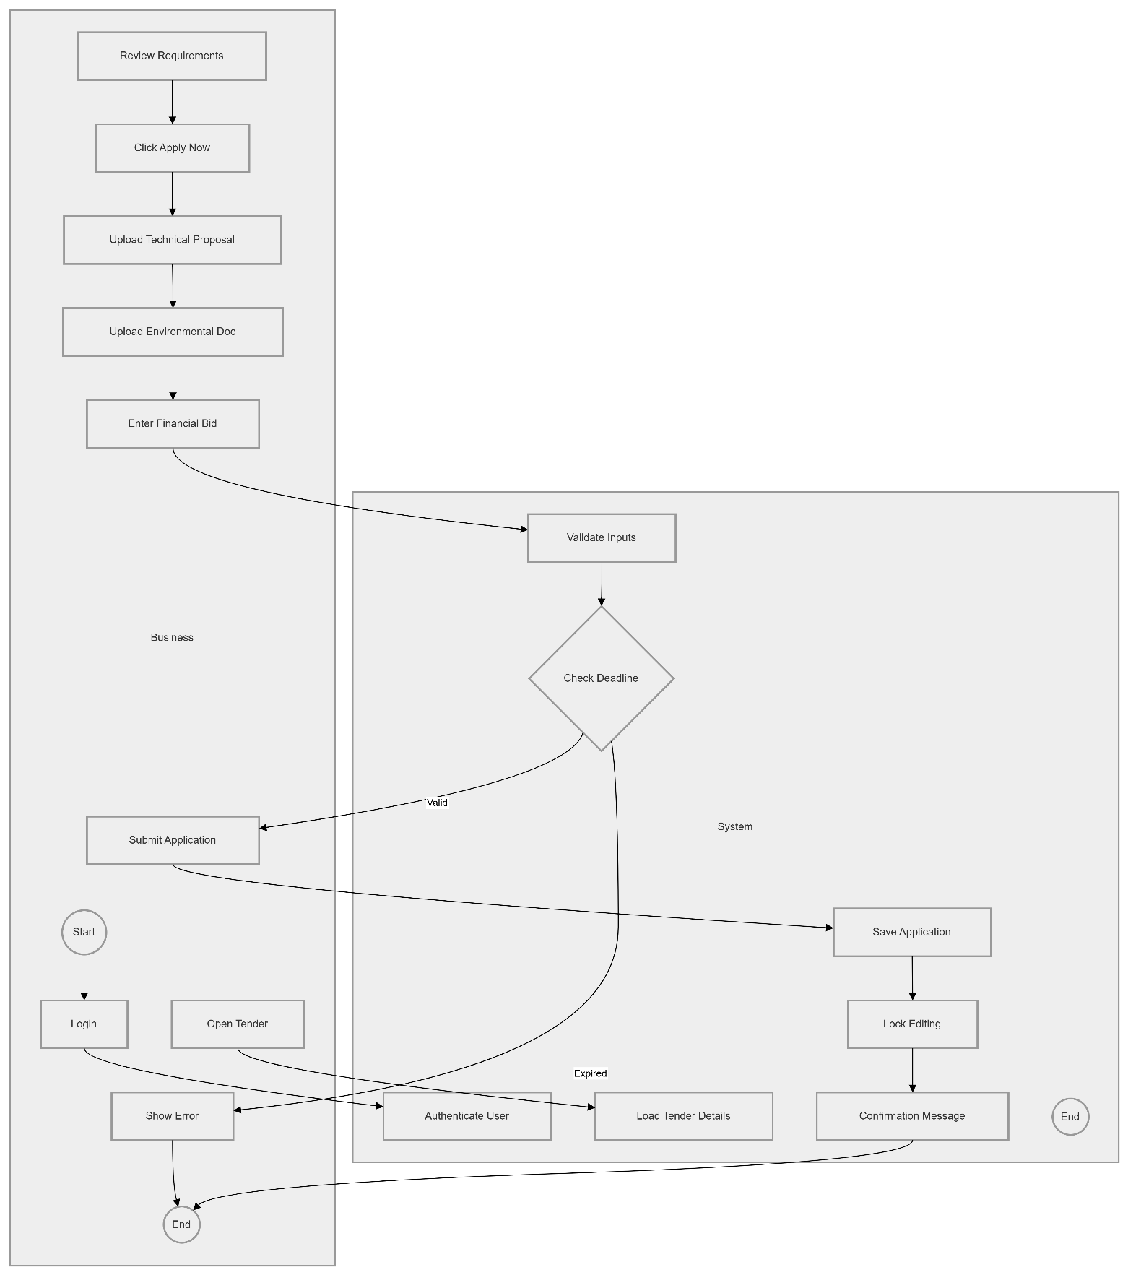
UC-08: Apply for Green Tender

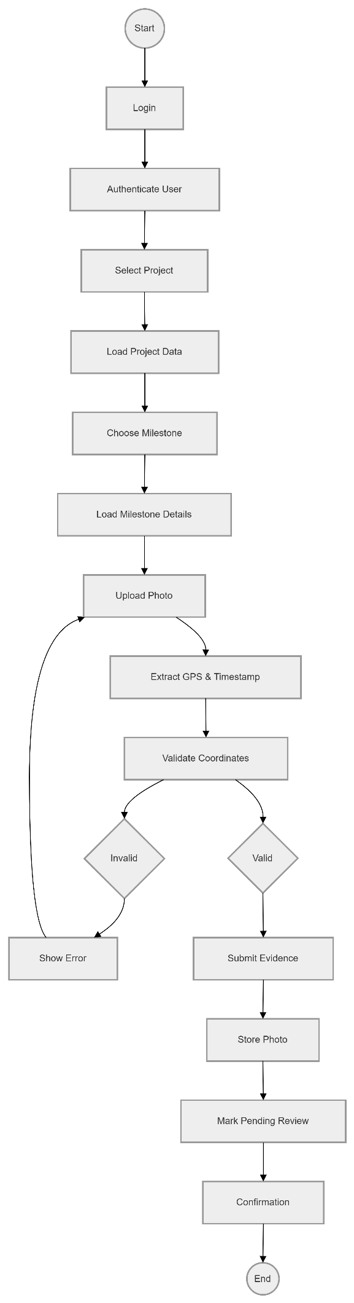
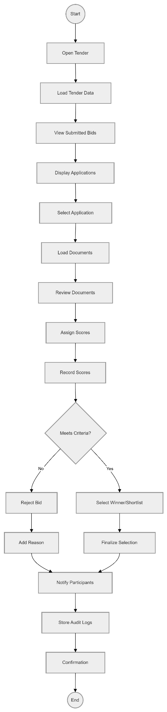
UC-09: Review UC-10: Upload
Photo Evidence
Business Bids



UC-11: Upload Legal Documents

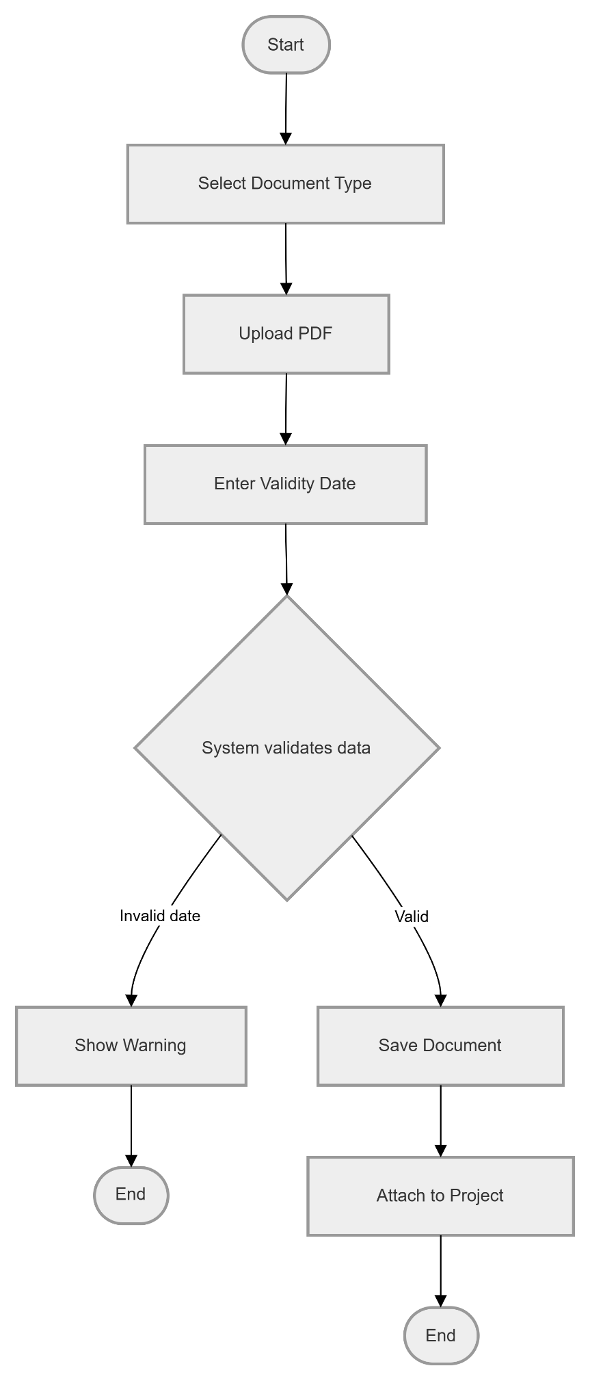



UC-12: Input Carbon Data
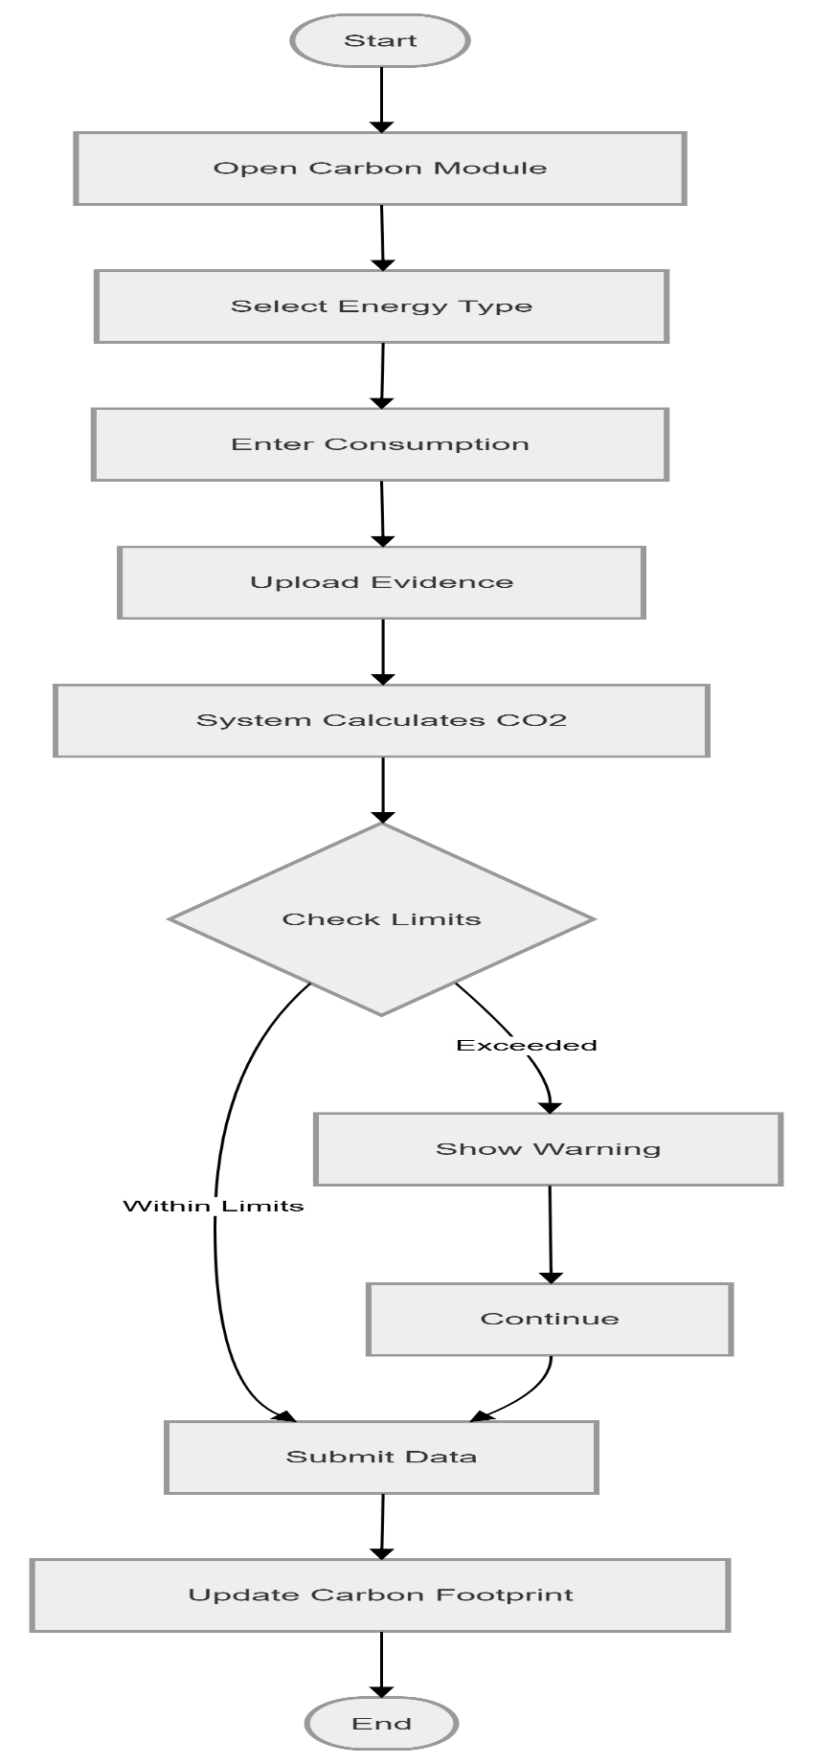

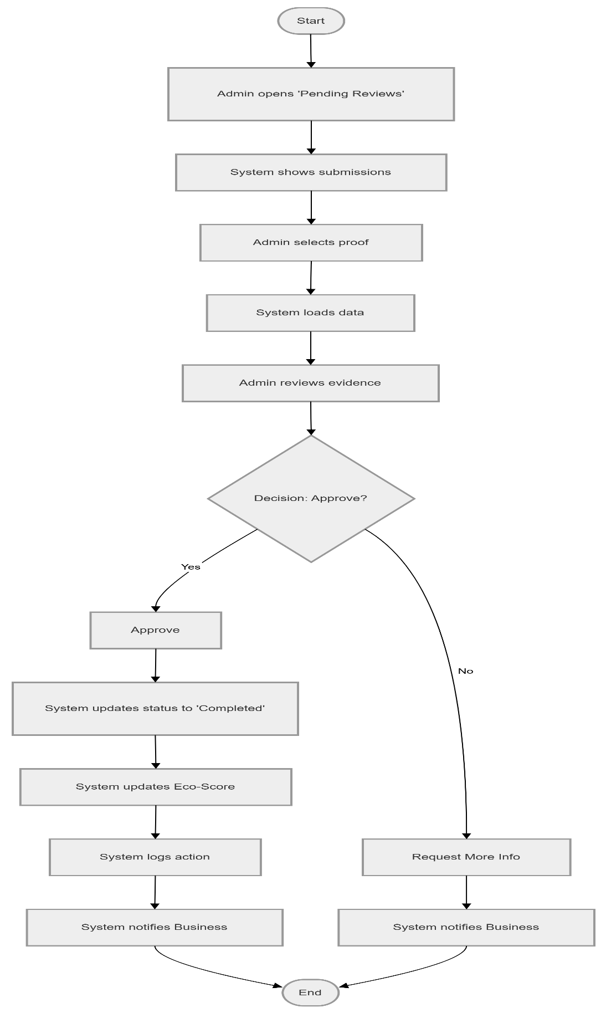
UC-13: Approve Compliance Proof

UC-14: Reject Compliance Proof
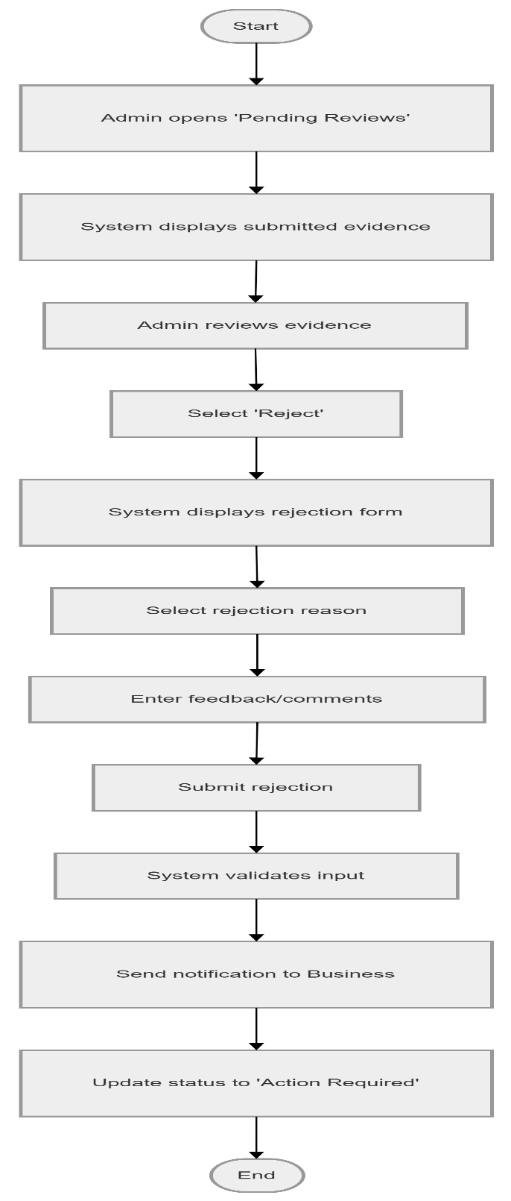

UC-15: Request Deadline Extension
